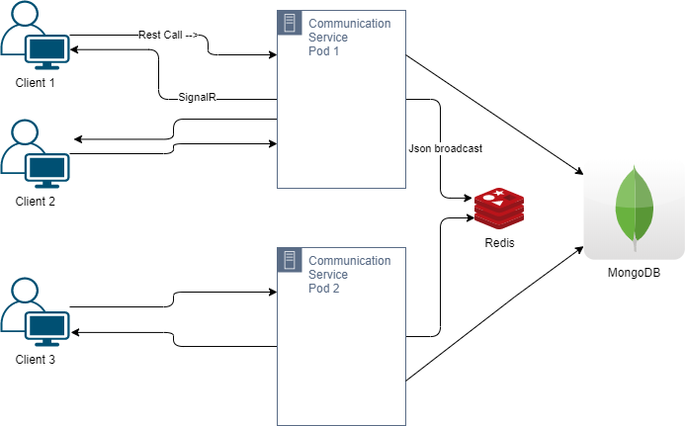

-Rest Call -

Communication Service Pod 1

Client 1

-SignalR

Json broadcast

Client 2

Redis

Communication Service Pod 2

MongoDB

О

Client 3